Git & GitHub Challenges:
1. Resolve Merge Conflicts
- Create a merge conflict intentionally (two users editing the same line).
- Resolve the conflict and push the changes.
Objective: To intentionally create a merge conflict between two branches (user-a and user-b), resolve it manually, and push the final merged code to the remote repository.

Step 1: Create user-a branch and commit changes
git checkout -b user-a
Create/modify file:
echo "Shared Line" > file.txt
Stage and commit:
git add file.txt
git commit -m "User A update"

Step 2: Create user-b branch from main
git checkout main
git checkout -b user-b
Modify the same file with a different change:
echo "Different Shared Line" > file.txt
Stage and commit:
git add file.txt
git commit -m "User B update"
Step 3: Merge branches into main
Switch to main:
git checkout main
Merge user-a: git merge user-a
Then merge user-b: git merge user-b

Expected Result: Merge Conflict
Git will show:
CONFLICT (content): Merge conflict in file.txt
Automatic merge failed; fix conflicts and then commit the result.

Step 4: Resolve the conflict manually
Open the file:
vi file.txt
You will see:
<<<<<<< HEAD
Shared Line
=======
Different Shared Line
>>>>>>> user-b

Resolution
Edit the file and choose a final version. Example:
Merged Version of Shared Line and Different Shared Line
Remove all conflict markers:
- <<<<<<< HEAD
- =======
- >>>>>>> user-b
Step 5: Mark conflict as resolved
git add file.txt
Commit the resolution:
git commit -m "Resolved merge conflict in file.txt"

Step 6: Push changes to remote repository
git push origin main

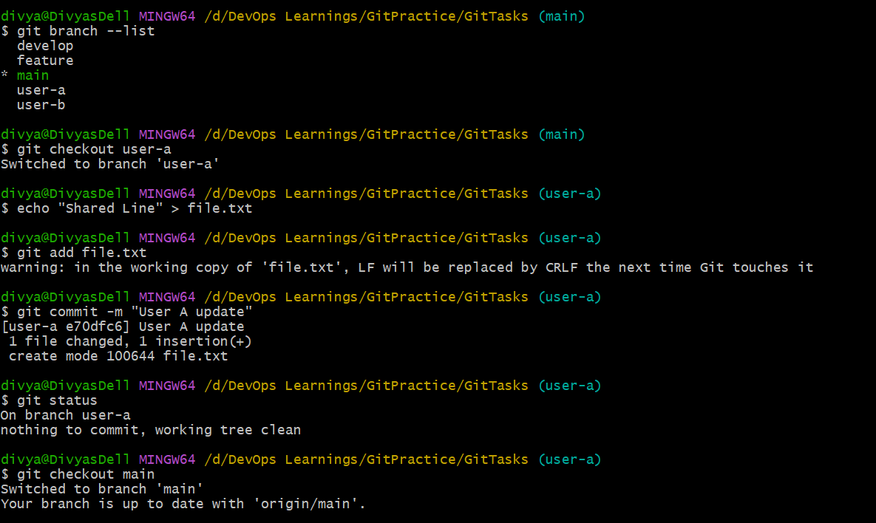
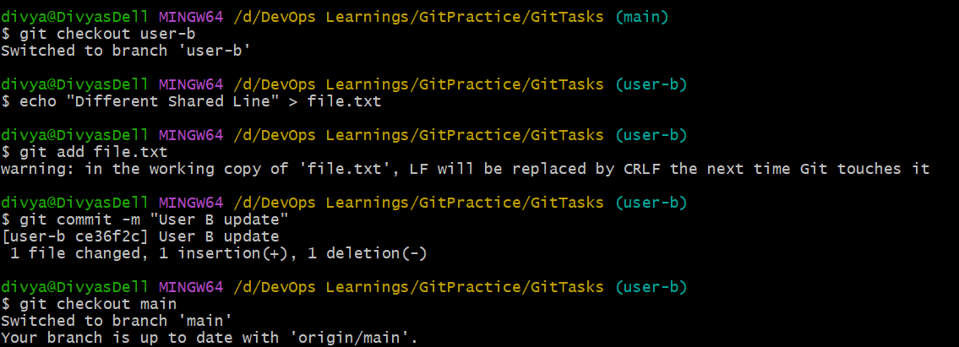
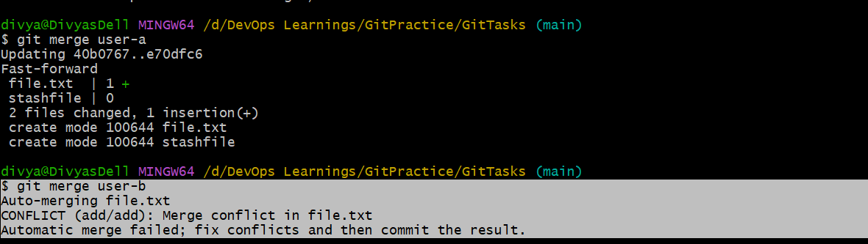
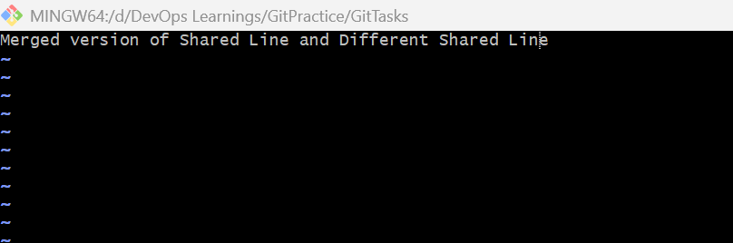
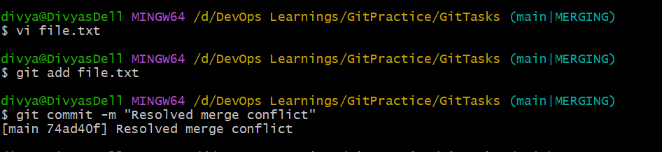
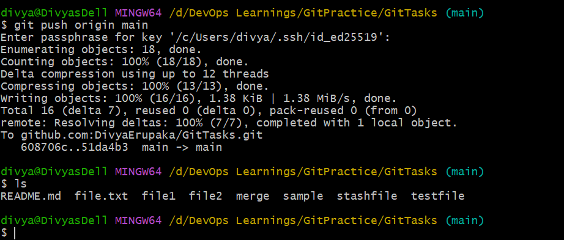
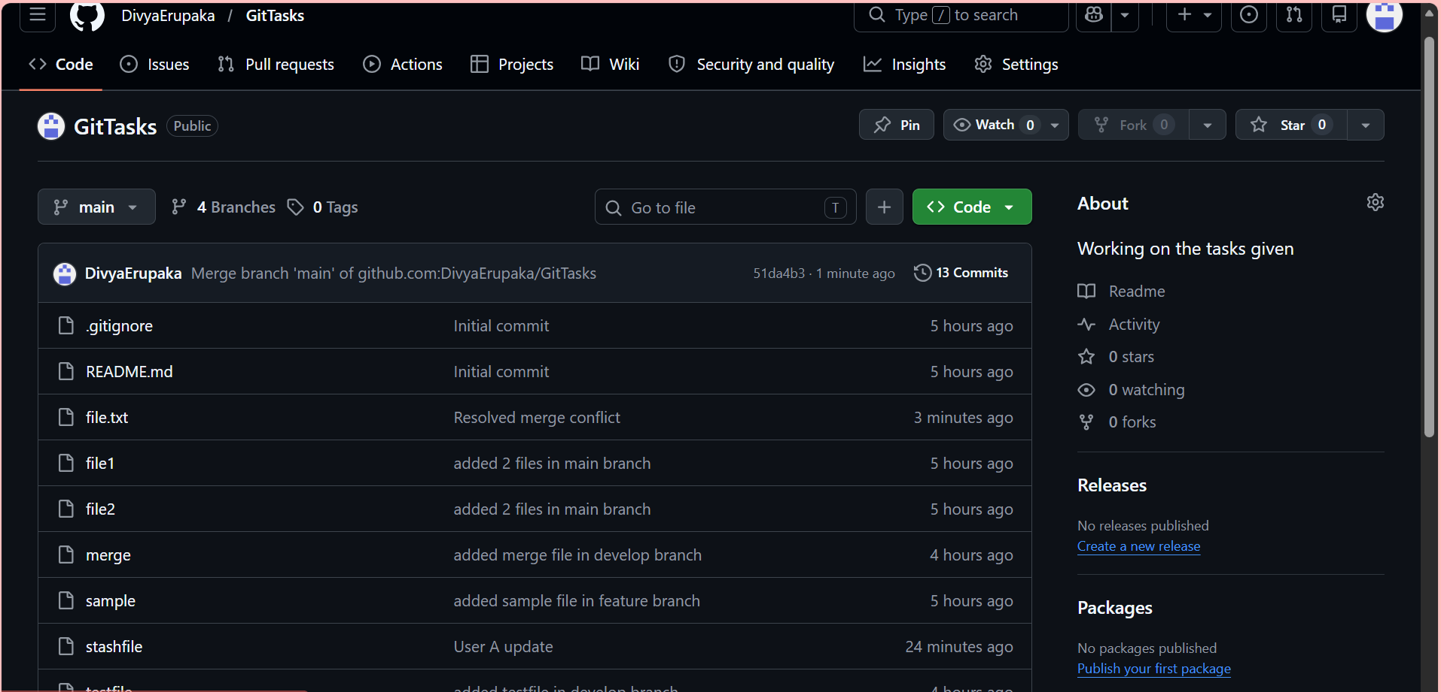
2. Recover Deleted Branch
- Delete a local branch and then recover it using the reflog.
Delete the branch locally
Switch away first (important):
git checkout main
Now delete the branch:
git branch -D feature-test
At this point
Your branch is gone from:
git branch
But Git has NOT truly deleted it yet (internally it still exists in history).
3. Find the deleted branch using reflog
Run:
git reflog
You will see output like:
abc1234 HEAD@{1}: checkout: moving from feature-test to main
def5678 HEAD@{2}: commit: Feature work commit
Find the commit hash of your deleted branch:
Example:
def5678
4. Recover the deleted branch
Now recreate the branch using that commit:
git checkout -b feature-test def5678
5. Verify recovery
git branch
You should see:
feature-test
main
6. (Optional) push recovered branch
git push origin feature

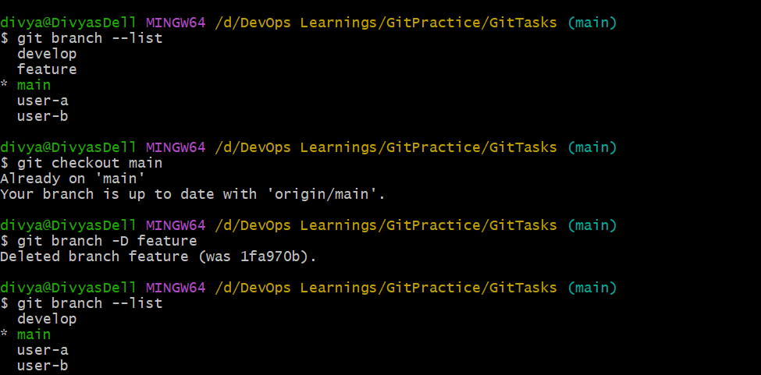
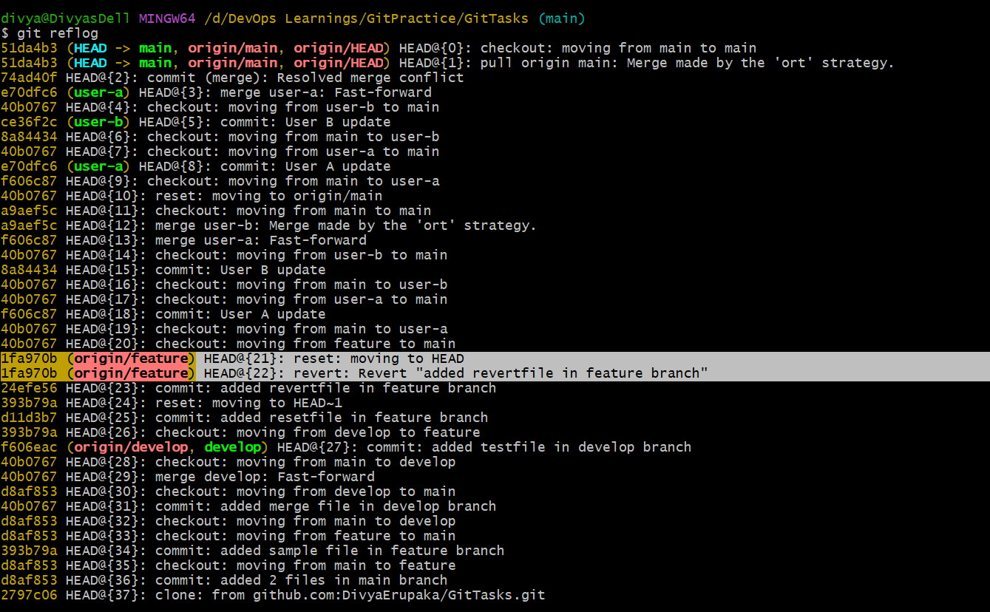
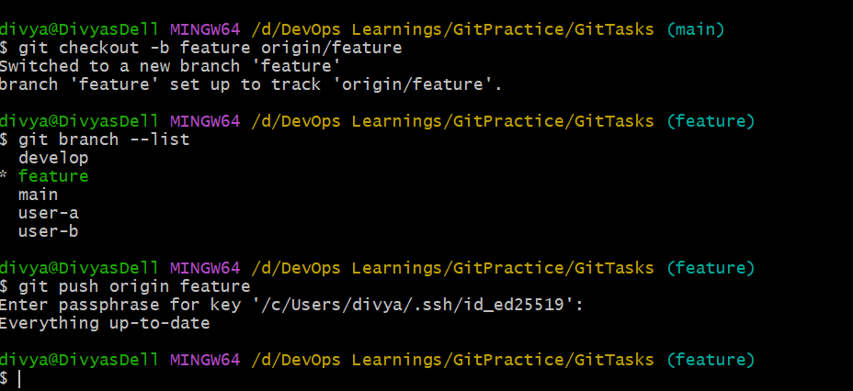
3. Undo Wrong Push
- Push a wrong commit to GitHub, then undo it without losing history.
Objective
To simulate a wrong commit pushed to GitHub and safely undo it using git revert without rewriting commit history.

Step 1: Create a wrong commit locally
Switch to main branch:
git checkout main
Create a wrong file:
echo "THIS IS A WRONG CHANGE" > wrong.txt
Stage the file:
git add wrong.txt
Commit the change:
git commit -m "Wrong commit: added incorrect file"

Step 2: Push wrong commit to GitHub
git push origin main

Step 3: Verify the wrong commit
Check locally:
git log --oneline -5
Check file exists:
ls
cat wrong.txt
Check remote sync:
git log origin/main --oneline -5

Problem Statement
A wrong commit has been pushed to the remote repository and must be undone without deleting Git history.

Step 4: Identify the wrong commit
git log --oneline
Copy the commit ID of the wrong commit:
<commit-id>

Step 5: Undo the wrong commit using revert
git revert <commit-id>
This creates a new commit that reverses the changes.

Step 6: Save revert commit message
If editor opens, save default message:
Revert "Wrong commit: added incorrect file"

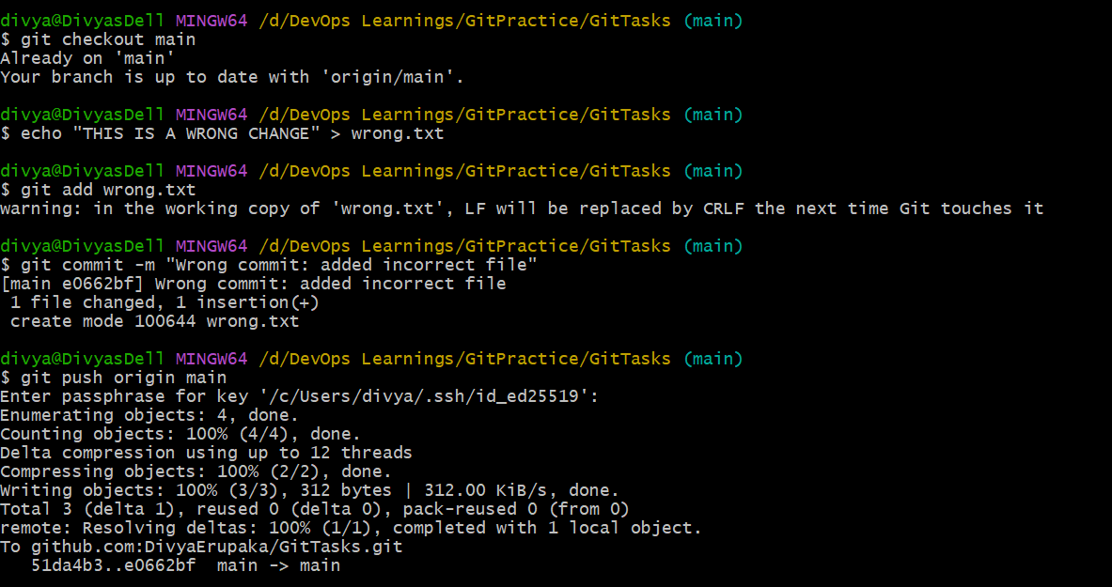
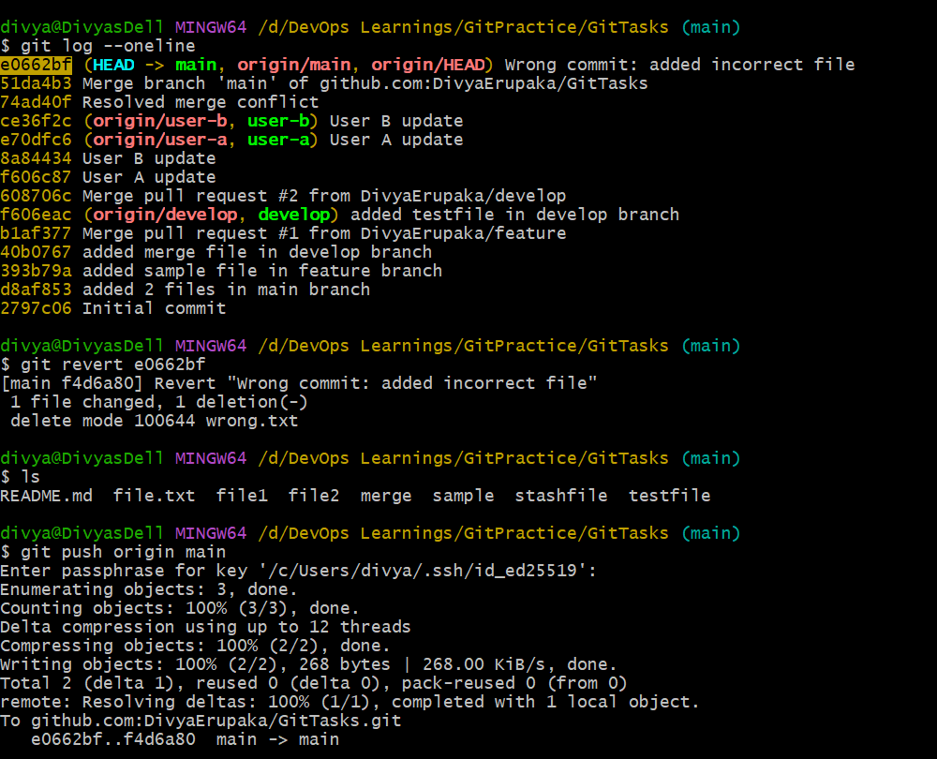
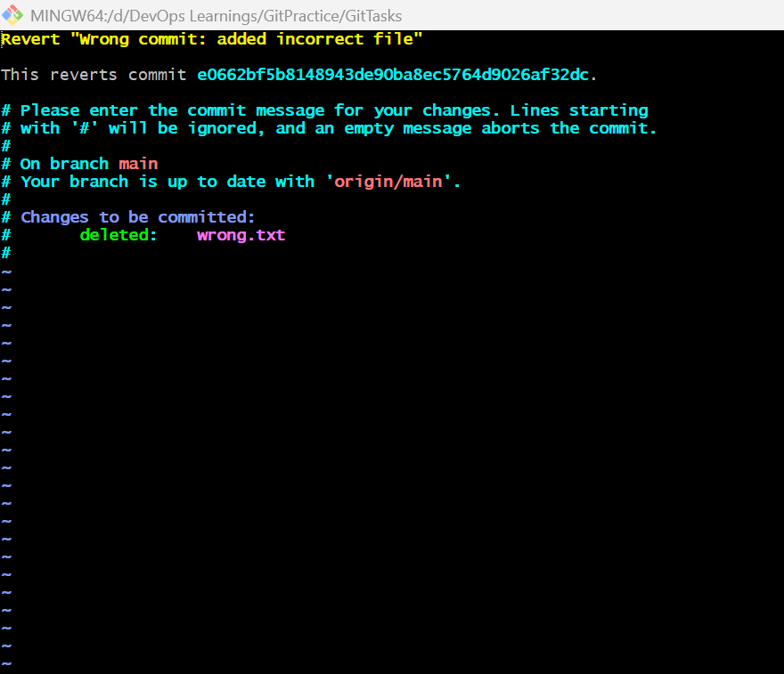
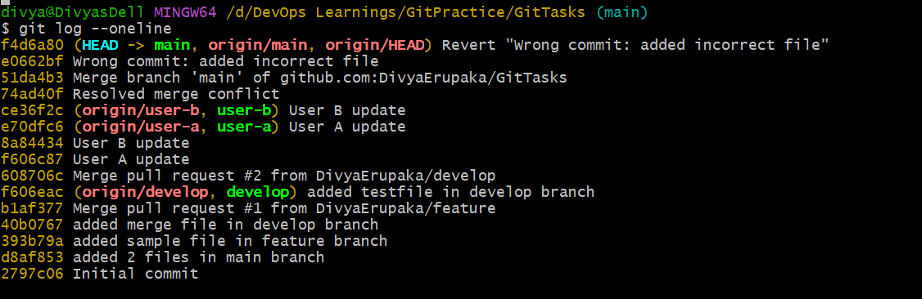
4. Amend a Commit
- Make a commit, then add a missing file to it usinggit commit --amend.
Objective: To create a commit and then modify it by adding a missing file using git commit --amend without creating a new commit.

Step 1: Create a new file and make initial commit
Switch to your working branch (example: main):
git checkout main
Create a file:
echo "Initial content file" > file1.txt
Stage and commit:
git add file1.txt
git commit -m "Initial commit with file1"
Step 2: Realize a file is missing
Now you realize you forgot to include another file.
Create the missing file:
echo "Missing file content" > file2.txt

Step 3: Stage the missing file
git add file2.txt

Step 4: Amend the previous commit
Instead of creating a new commit, update the last one:
git commit --amend
OR with updated message:
git commit --amend -m "Updated commit with file1 and file2"

Step 5: Verify commit change
Check commit history:
git log --oneline -3
You will see:
- Only one commit updated
- No second commit created

Step 6: Verify files in commit
ls
Expected output:
file1.txt
file2.txt

Step 7: Push changes to GitHub
If already pushed before the amendment:
git push origin main
If Git rejects push (common after amend):
git push --force origin main

Key Learning
- git commit --amend modifies the last commit only
- It can:
  - add missing files
  - change commit message
- It rewrites commit history locally

Important Note
Situation | Safe?
Local commit not pushed | ✔ Safe
Already pushed commit | ⚠ Requires force push
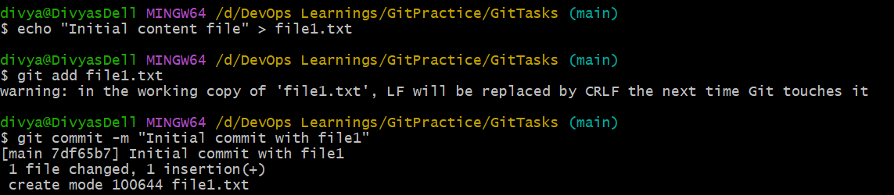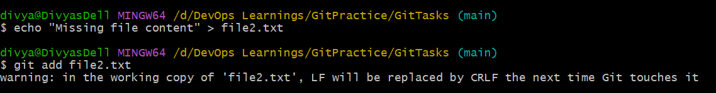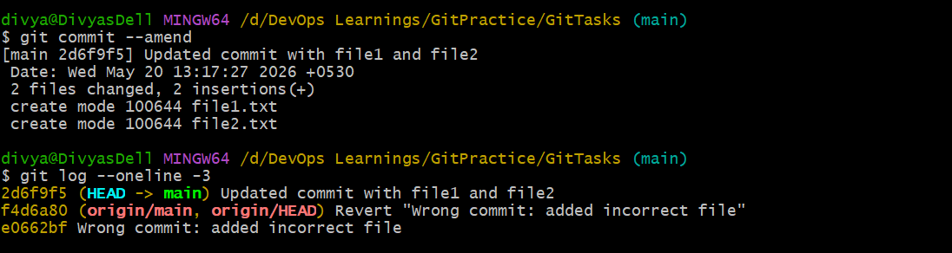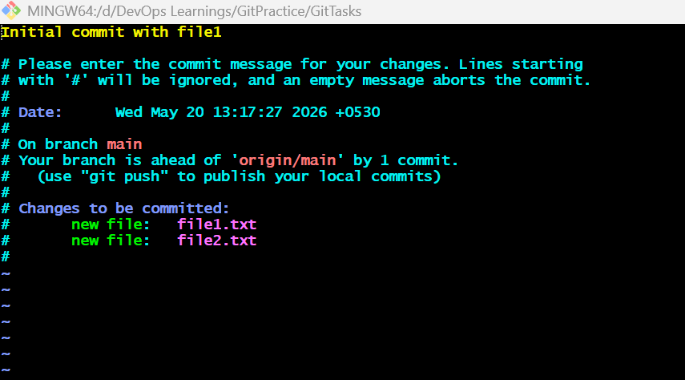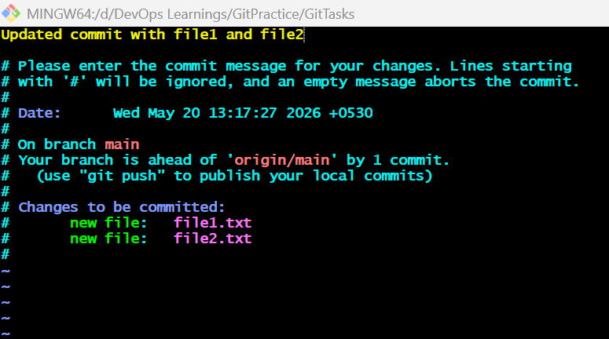
5. Cherry-pick a Commit
- Take a specific commit from one branch and apply it to another branch.
Objective: To take a specific commit from one branch and apply it to another branch using git cherry-pick.

What is Cherry-Pick?
git cherry-pick allows you to apply a single commit from one branch into another branch without merging the entire branch.

Step 1: Create a source branch and commit
Switch to main (or any base branch):
git checkout main
Create a new branch:
git checkout -b feature-branch
Create a file:
echo "Feature work - commit 1" > feature.txt
git add feature.txt
git commit -m "Add feature file"

Step 2: Get commit ID
Check commit history:
git log --oneline
Example output:
abc1234 Add feature file
Copy commit ID: abc1234

Step 3: Switch to target branch
Go back to main:
git checkout main

Step 4: Cherry-pick the commit
Apply the specific commit:
git cherry-pick abc1234
Step 5: Verify result
Check commit history:
git log --oneline
You will see the same commit now in main.
Check file:
ls
cat feature.txt

Step 6: Push changes to GitHub
git push origin main

Key Learning
- git cherry-pick copies a single commit
- It does NOT merge the whole branch
- It creates a new commit with same changes

Important Notes
Situation | Behavior
Same commit applied twice | Git may conflict or duplicate
Works on clean target branch | ✔ Best case
Conflicts during cherry-pick | Must resolve manually

Summary Flow
git checkout feature-branch
git commit -m "some commit"
git checkout main
git cherry-pick <commit-id>
git push origin main

Conclusion: This exercise demonstrates how to selectively move a commit from one branch to another without merging the full branch using git cherry-pick.

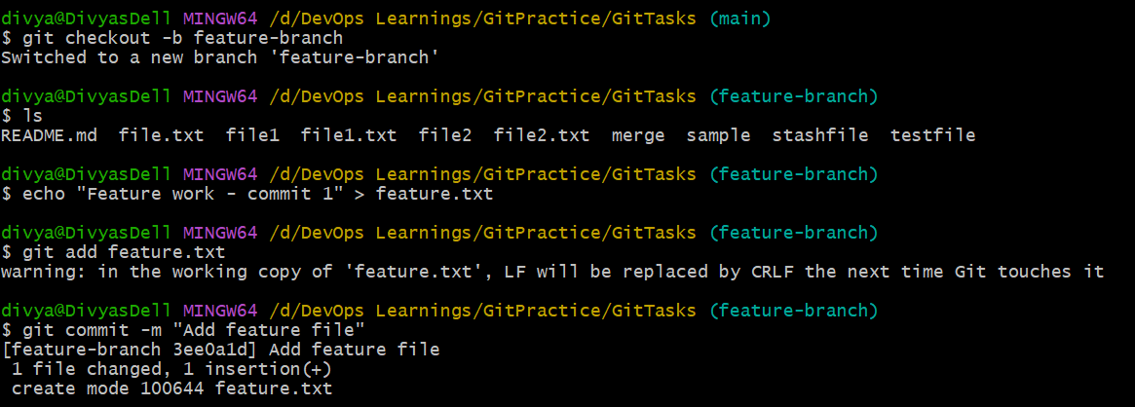
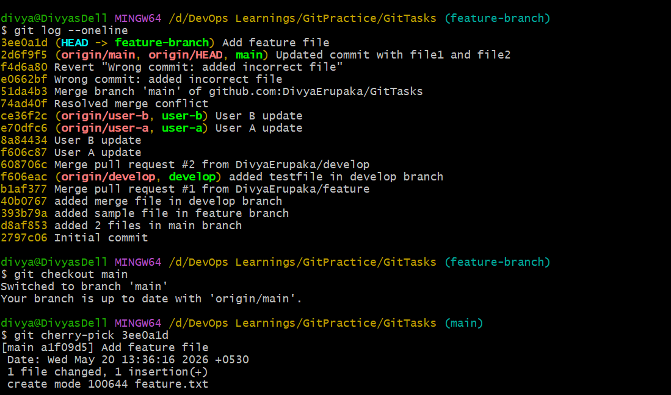
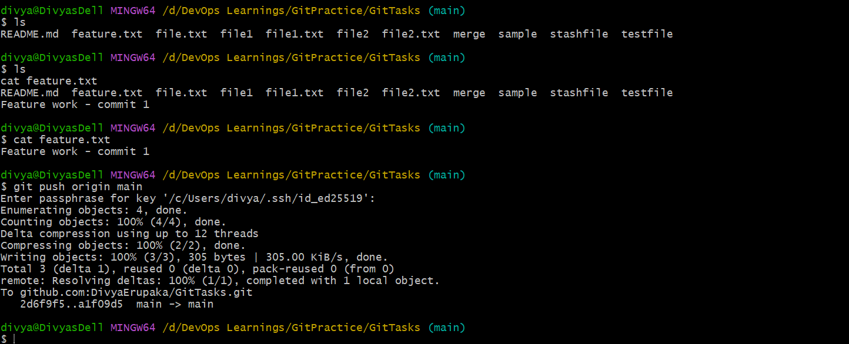
6. Interactive Rebase
- Reorder and squash multiple commits into a single clean commit.
Objective: To clean up commit history by reordering commits and squashing multiple commits into a single commit using interactive rebase.

What is Interactive Rebase?
git rebase -i allows you to modify commit history by:
- Reordering commits
- Squashing multiple commits into one
- Editing commit messages
- Removing unwanted commits

Step 1: Create multiple commits
Switch to a branch:
git checkout main
git checkout -b rebase-demo
Create first change:
echo "Line 1" > file.txt
git add file.txt
git commit -m "Add line 1"
Create second change:
echo "Line 2" >> file.txt
git add file.txt
git commit -m "Add line 2"
Create third change:
echo "Line 3" >> file.txt
git add file.txt
git commit -m "Add line 3"
Check history:
git log --oneline
Example:
c3 Add line 3
b2 Add line 2
a1 Add line 1

Step 2: Start interactive rebase
Go back 3 commits:
git rebase -i HEAD~3
Step 3: Rebase editor opens
You will see:
pick a1 Add line 1
pick b2 Add line 2
pick c3 Add line 3

Step 4: Squash commits
Change to:
pick a1 Add line 1
squash b2 Add line 2
squash c3 Add line 3

Step 5: Edit final commit message
Git will open another editor:
You can change to:
Final combined feature update (lines 1, 2, 3)

Step 6: Verify result
Check commit history:
git log --oneline
Now you will see:
xyz123 Final combined feature update
Multiple commits → one clean commit

Step 7: Push changes
If already pushed before rebase:
git push --force origin rebase-demo
If not pushed yet:
git push origin rebase-demo

Key Learning
- rebase -i rewrites commit history
- squash combines commits
- pick keeps commit as-is
- Used to clean messy commit history
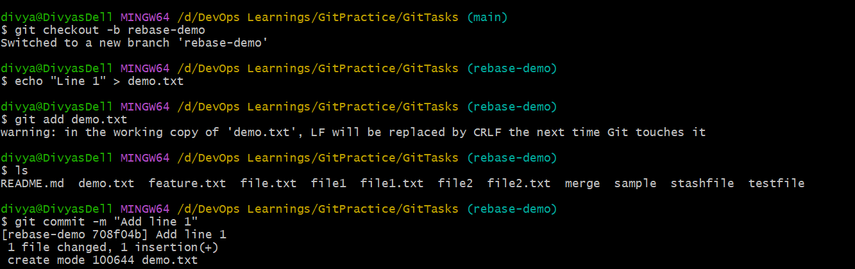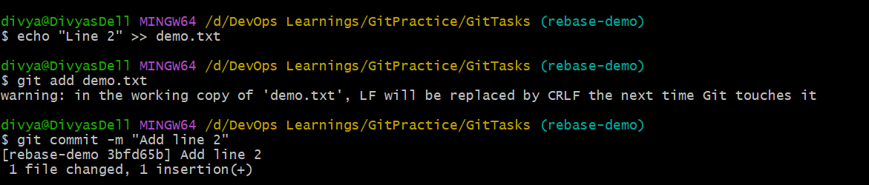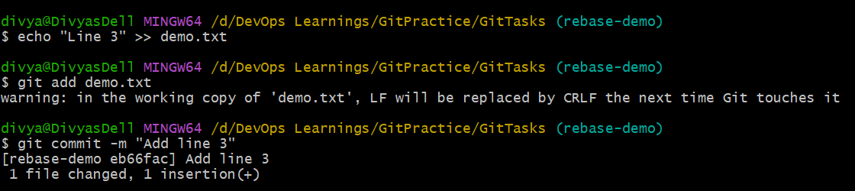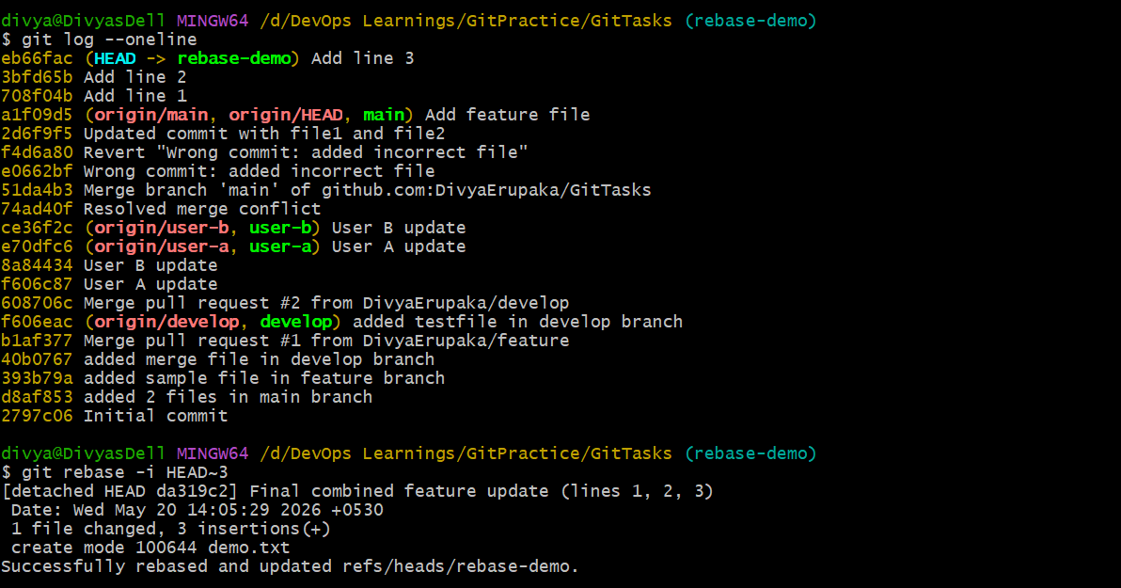
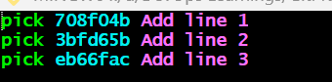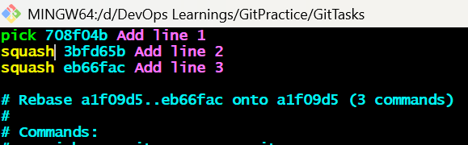
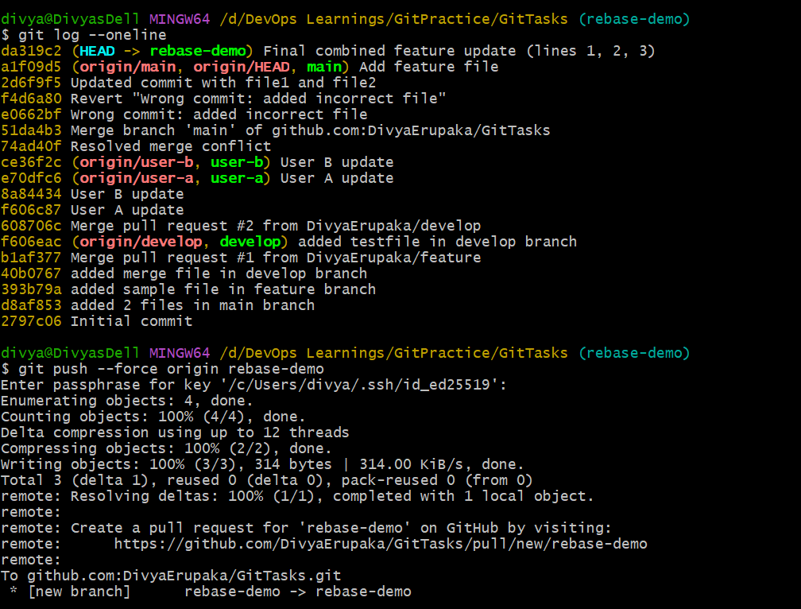
7. Tagging & Release
- Create a version tag (v1.0), push it to GitHub, then delete and restore it.
Objective: To create a version tag (v1.0), push it to GitHub, delete it locally and remotely, and finally restore it using Git.

What is a Git Tag?
A tag is a reference to a specific commit, used to mark release versions like v1.0, v2.0, etc.

Step 1: Create a version tag
Switch to main branch:
git checkout main
Create a tag:
git tag v1.0

(Optional) Create annotated tag (recommended for releases)
git tag -a v1.0 -m "First release version 1.0"

Step 2: Push tag to GitHub
Push single tag:
git push origin v1.0
OR push all tags:
git push origin --tags

Step 3: Verify tag
Check locally:
git tag
Check details:
git show v1.0
On GitHub:
- Go to Tags section
- You should see v1.0
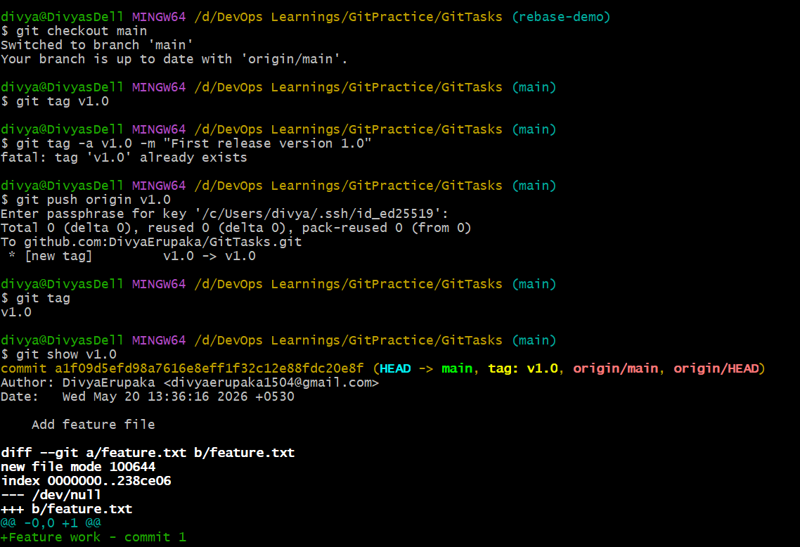

Step 4: Delete the tag (local + remote)
Delete local tag:
git tag -d v1.0
Delete remote tag:
git push origin --delete v1.0
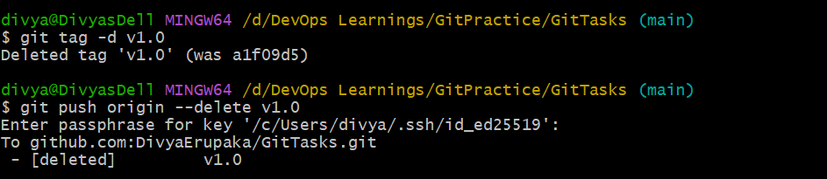
Step 5: Restore the deleted tag
Find commit again:
git log --oneline
Copy the commit hash where tag was created.

Recreate tag:
git tag v1.0 <commit-id>
Example:
git tag v1.0 51da4b3

Push restored tag:
git push origin v1.0

Final Result
On GitHub:
- Tag v1.0 is restored
- Points to correct commit
- Works like a release marker

Key Learning
- Tags are fixed pointers to commits
- They are used for releases (v1.0, v2.0)
- Deleting a tag does NOT delete commits
- Tags can be recreated anytime using commit hash

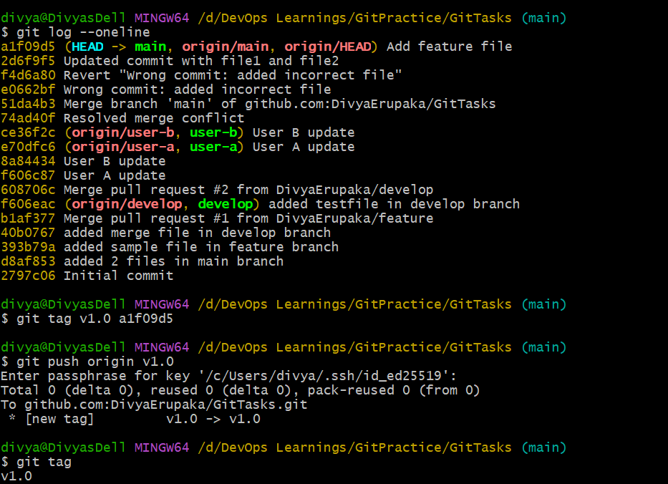
8. Clone with Sparse Checkout
- Clone only a subdirectory of a repo using sparse checkout. Objective
Objective: To clone only specific folders (src/, resources/) from a GitHub repository using sparse checkout, instead of downloading the full repository.

Concept
Sparse checkout allows you to selectively download and view only required directories from a repository, making it useful for large projects.

Step 1: Clone repository without checkout
git clone --no-checkout https://github.com/githubtraining/hellogitworld.git hellogit-sparse

Step 2: Enter repository
cd hellogit-sparse

Step 3: Enable sparse checkout (cone mode)
git sparse-checkout init --cone

Step 4: Check repository structure
ls
Expected folders (based on repo structure):
src/
resources/

Step 5: Select only required folder
Example: show only src/
git sparse-checkout set src

Step 6: Checkout correct branch
git checkout main

Expected Result
After checkout, your working directory should contain:
src/
Only the selected folder will be visible.

Step 7: Verify sparse checkout configuration
git sparse-checkout list
Expected output:
src

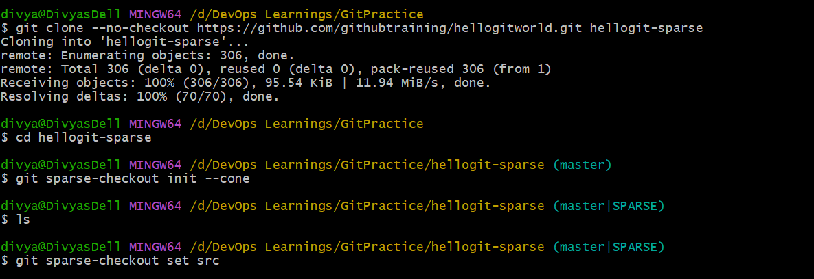
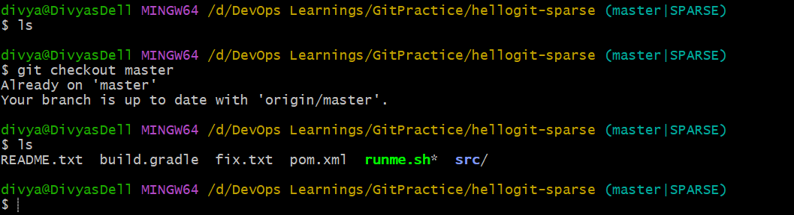
9. Reset vs Revert Challenge
- Demonstrate the difference betweengit reset --hardandgit revertin a repo.
Objective: To demonstrate the difference between:
- git reset --hard (rewrites history)
- git revert (safely undoes changes with history preserved)

Core Concept
Command | Behavior | Safe for shared repo?
git reset --hard | Deletes commits from history | No
git revert | Creates new commit to undo changes | Yes

Step 1: Create sample commits
git checkout main
Create a file:
echo "Version 1" > demo.txt
git add demo.txt
git commit -m "Add Version 1"
Update file:
echo "Version 2" >> demo.txt
git add demo.txt
git commit -m "Add Version 2"
Update again:
echo "Version 3" >> demo.txt
git add demo.txt
git commit -m "Add Version 3"
Check history:
git log --oneline

Part 1: Demonstrate git revert (SAFE)
Step 2: Revert last commit
git revert HEAD

What happens
- A new commit is created
- Last change is undone
- History remains intact
Check:
git log --oneline
You will see:
Revert "Add Version 3"
Add Version 3
Add Version 2
Add Version 1
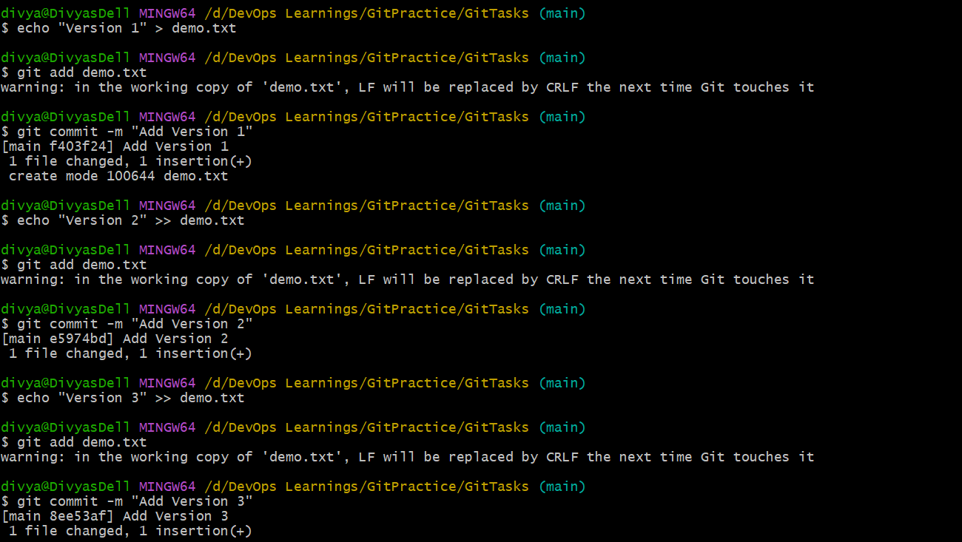
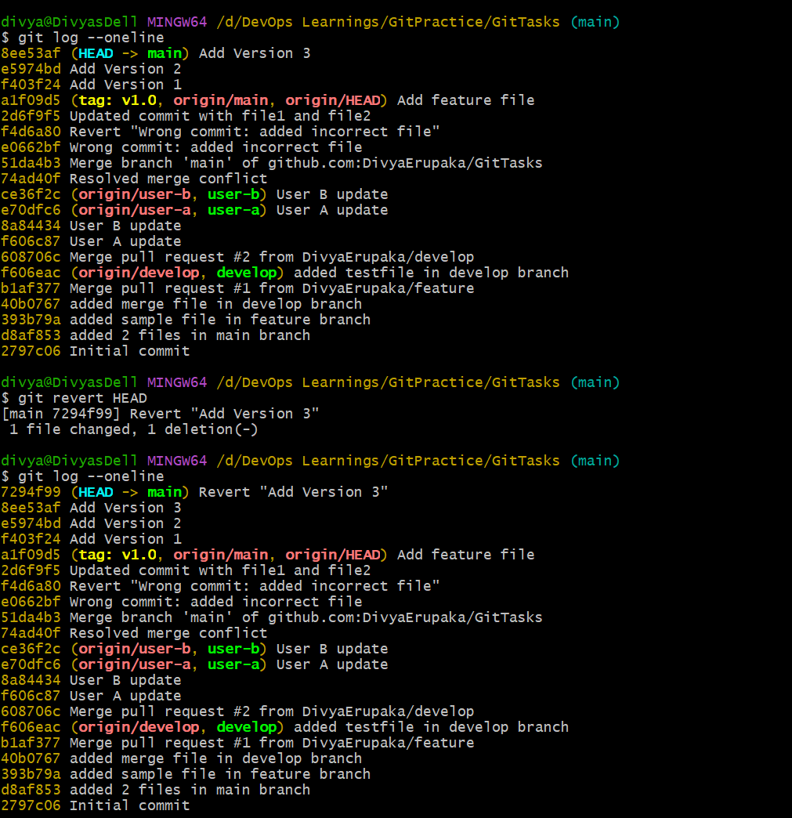
Part 2: Demonstrate git reset --hard
Only do this in practice repo (NOT shared repo)

Reset to previous commit
git reset --hard HEAD~1

What happens
- Last commit is completely removed
- No revert commit is created
- History is rewritten
Check:
git log --oneline
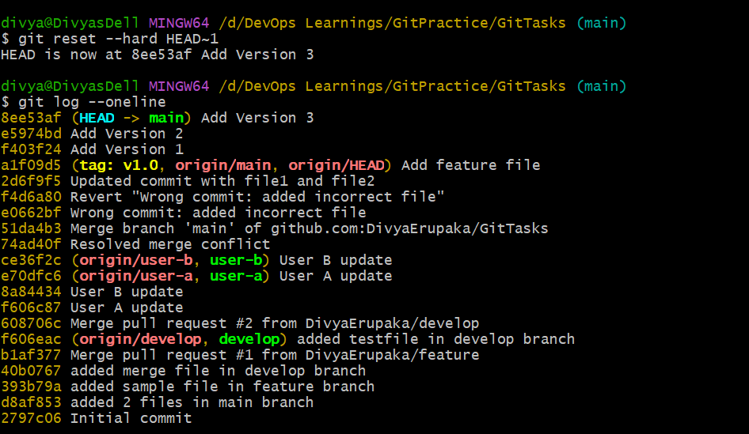
10. Detached HEAD Challenge
- Check out a specific commit (detached HEAD state) and create a new branch from it.
Objective: To understand the detached HEAD state by checking out a specific commit and then creating a new branch from it.
Concept
A detached HEAD state occurs when Git points directly to a commit rather than a branch.
You can view or test old commits
New commits are not attached to any branch (unless you create one)
Step 1: Pick a commit (safe point)
From your log, choose this commit:
a1f09d5 Add feature file
This is good because it already exists in remote too.

Step 2: Checkout commit (Detached HEAD)
git checkout a1f09d5

What you will see
HEAD detached at a1f09d5
You are now NOT on main

Step 3: Confirm state
git status
Expected:
HEAD detached at a1f09d5

Step 4: Make a change
echo "Detached HEAD test file" > detached-demo.txt
git add detached-demo.txt
git commit -m "Detached HEAD experiment commit"

IMPORTANT MOMENT
Now this commit:
exists
is NOT on any branch
If you switch branches now → it can be lost

Step 5: Save work properly (create branch)
git checkout -b detached-fix-branch

Now your work is SAFE
✔ Commit is now part of a branch
✔ No data loss
✔ Ready to push

Step 6: Push new branch
git push origin detached-fix-branch

Visual Understanding
Before:
main → 8ee53af → e5974bd → f403f24
Detached HEAD:
HEAD → a1f09d5 (no branch)
After branch creation:
main → 8ee53af → e5974bd → f403f24
↳ detached-fix-branch

Key Learning
Concept | Meaning
Detached HEAD | Working directly on a commit
Risk | Work is not attached to branch
Fix | Create branch from HEAD
Use case | debugging / rollback testing

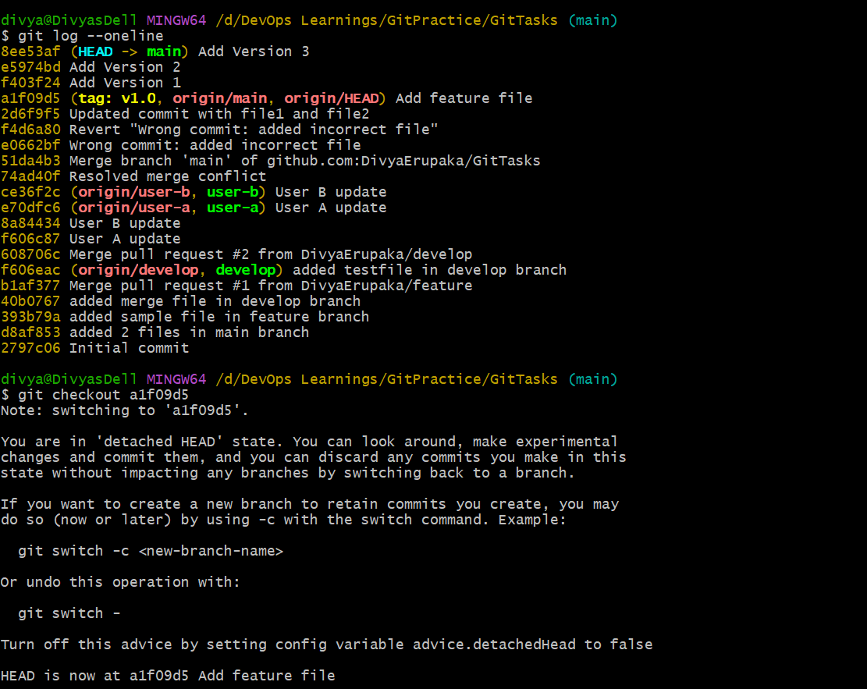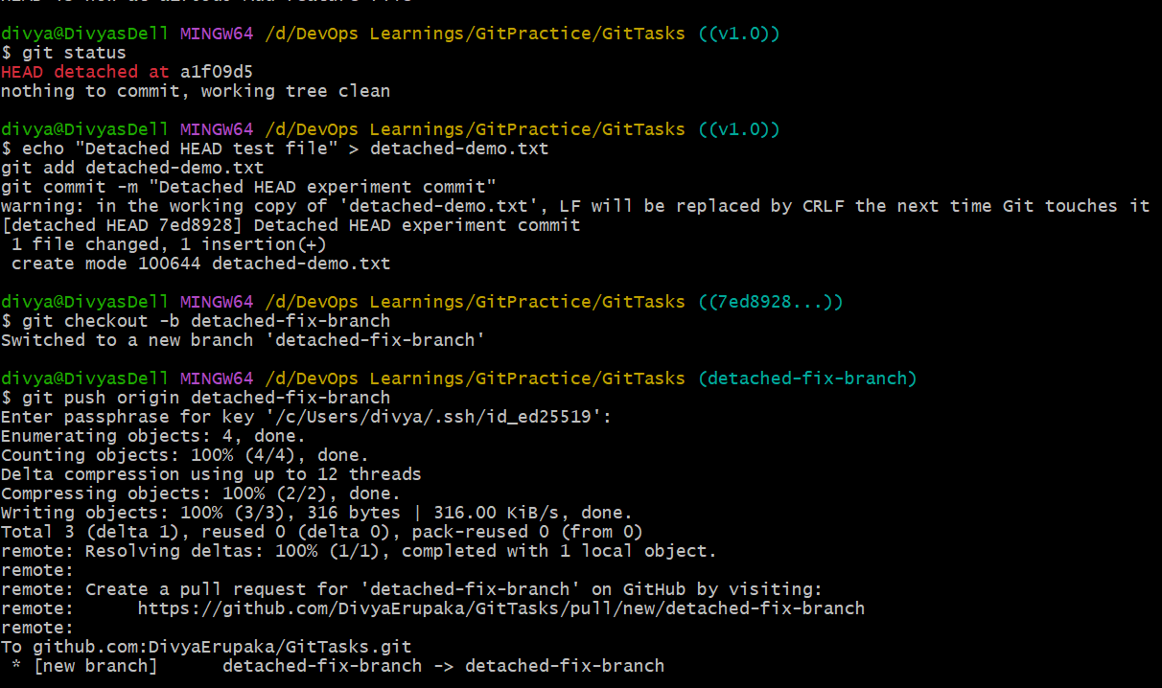
11. Git Hooks Challenge
- Configure apre-commithook to reject commits without a message format (e.g., must start withJIRA-XXX).
Objective: Configure a Git hook that rejects commits unless the commit message follows a required format:
JIRA-XXX <message>
Example:
- JIRA-101 Fix login bug
- fix login bug
- updated file

Concept: Git hooks are local automation scripts that run automatically during Git events.
For this task, the correct hook is:
commit-msg hook (NOT pre-commit)
Because:
- pre-commit → checks code/files
- commit-msg → validates commit message

Step 1: Go to repository hooks folder
cd .git/hooks
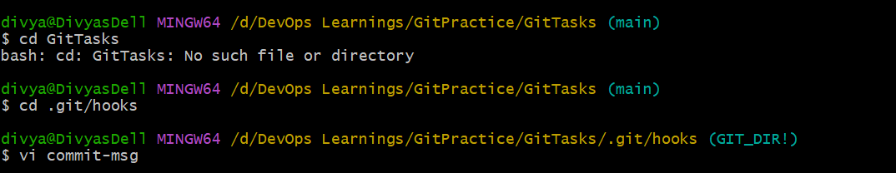

Step 2: Create commit-msg hook
Create file:
vi commit-msg
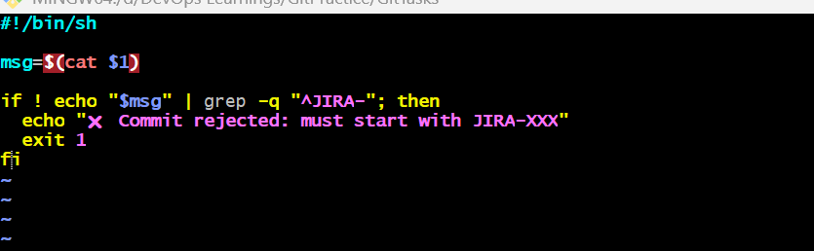
Step 3: Add validation script
#!/bin/sh
msg=$(cat $1)
if ! echo "$msg" | grep -q "^JIRA-"; then
echo " Commit rejected: must start with JIRA-XXX"
exit 1
fi
Step 4: Make hook executable
chmod +x commit-msg

Step 5: Create a test file
Go to repo root:
cd ../..
echo "testing hooks" > hook-test.txt
git add hook-test.txt

Step 6: Test invalid commit (should FAIL)
git commit -m "fix bug"
Expected Output:
Commit rejected!
Format required: JIRA-XXX <message>

Step 7: Test valid commit (should PASS)
git commit -m "JIRA-101 Fix login bug"
Commit succeeds

Key Learning
Concept | Meaning
Git hooks | Local automation scripts
commit-msg | Validates commit messages
exit 1 | Blocks commit
exit 0 | Allows commit
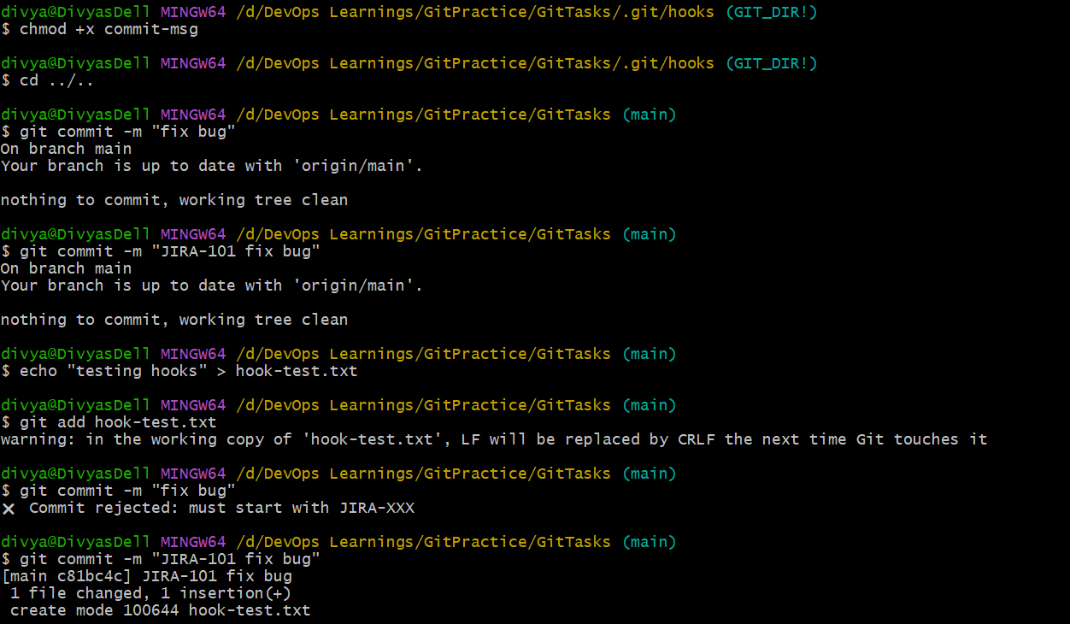
12. Squash Merge vs Rebase Merge
- Show the difference between squash merge and rebase merge with evidence.
Objective: To demonstrate the difference between:
- Squash Merge
- Rebase Merge
and show how commit history changes in each case.

Core Concept
Type | What it does | Result in history
Squash Merge | Combines all commits into ONE commit | Clean single commit
Rebase Merge | Replays commits one-by-one on target branch | Linear history (no merge commit)

Step 1: Create feature branch
git checkout main
git checkout -b feature-demo

Step 2: Create multiple commits
echo "line 1" >> demo.txt
git add demo.txt
git commit -m "Feature part 1"
echo "line 2" >> demo.txt
git add demo.txt
git commit -m "Feature part 2"
echo "line 3" >> demo.txt
git add demo.txt
git commit -m "Feature part 3"

Check feature branch history
git log --oneline
Expected:
C3 Feature part 3
C2 Feature part 2
C1 Feature part 1

PART 1: Squash Merge
Step 3: Go to main
git checkout main

Step 4: Squash merge feature branch
git merge --squash feature-demo

Step 5: Commit result
git commit -m "Feature implemented (squash merge)"

Evidence (Squash result)
git log --oneline
Output:
Feature implemented (squash merge)
All feature commits become ONE commit

PART 2: Rebase Merge (reset and redo demo)
Step 6: Reset main (clean state)
git reset --hard HEAD~1

Step 7: Rebase merge feature branch
git checkout main
git rebase feature-demo

Evidence (Rebase result)
git log --oneline
Output:
C3 Feature part 3
C2 Feature part 2
C1 Feature part 1
(main pointer moved here)
All commits preserved
No merge commit created
Linear history

Final Comparison (Evidence-based)
Feature | Squash Merge | Rebase Merge
Commit count | 1 commit | All commits preserved
History style | Flattened | Linear
Merge commit | No | No
Traceability | Low | High
Best use case | Clean PR history | Clean linear history
13. Fork & Pull Request Workflow
- Fork a repo, make a change, and submit a pull request to the original repo
Objective: To understand the real-world Git collaboration flow:
- Fork a repository
- Clone your fork
- Make changes in a feature branch
- Push changes to your fork
- Create a Pull Request (PR) to the original repo

Concept
Term | Meaning
Fork | Copy of someone else’s repo under your GitHub account
Clone | Download repo to local machine
Pull Request (PR) | Request to merge your changes into original repo

Step 1: Fork the repository
Go to GitHub:
Example repo:
https://github.com/githubtraining/hellogitworld
Click:
Fork → Create fork (your account)

Step 2: Clone your fork
git clone https://github.com/<your-username>/hellogitworld.git
cd hellogitworld
Step 3: Create a new branch
git checkout -b feature-update

Step 4: Make changes
Example:
echo "My contribution change" >> README.md

Step 5: Stage and commit
git add README.md
git commit -m "JIRA-101 Added my contribution via fork workflow"

Step 6: Push to your fork
git push origin feature-update

Step 7: Create Pull Request (PR)
Go to GitHub:
👉 Your fork repo
You will see:
Compare & Pull Request
Click it and fill:
- Base repo: original repo
- Base branch: main
- Head repo: your fork
- Compare branch: feature-update
Click:
Create Pull Request

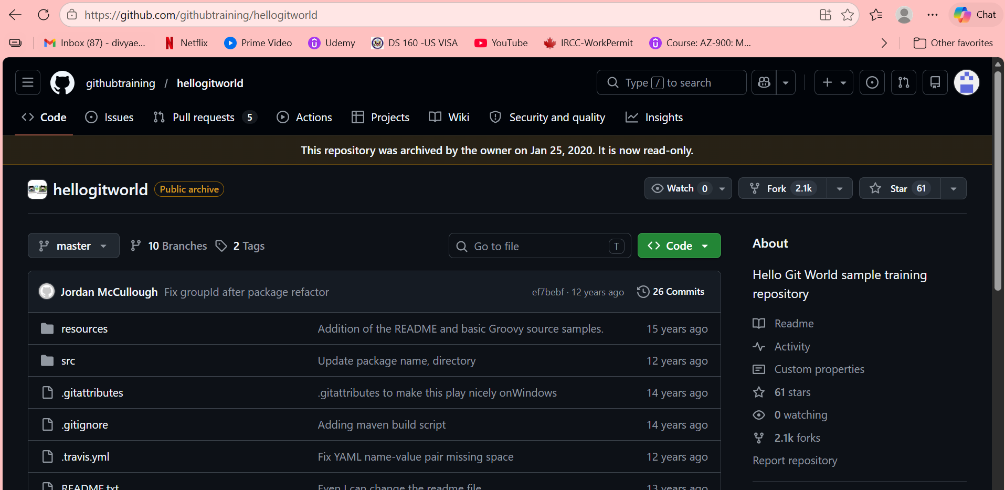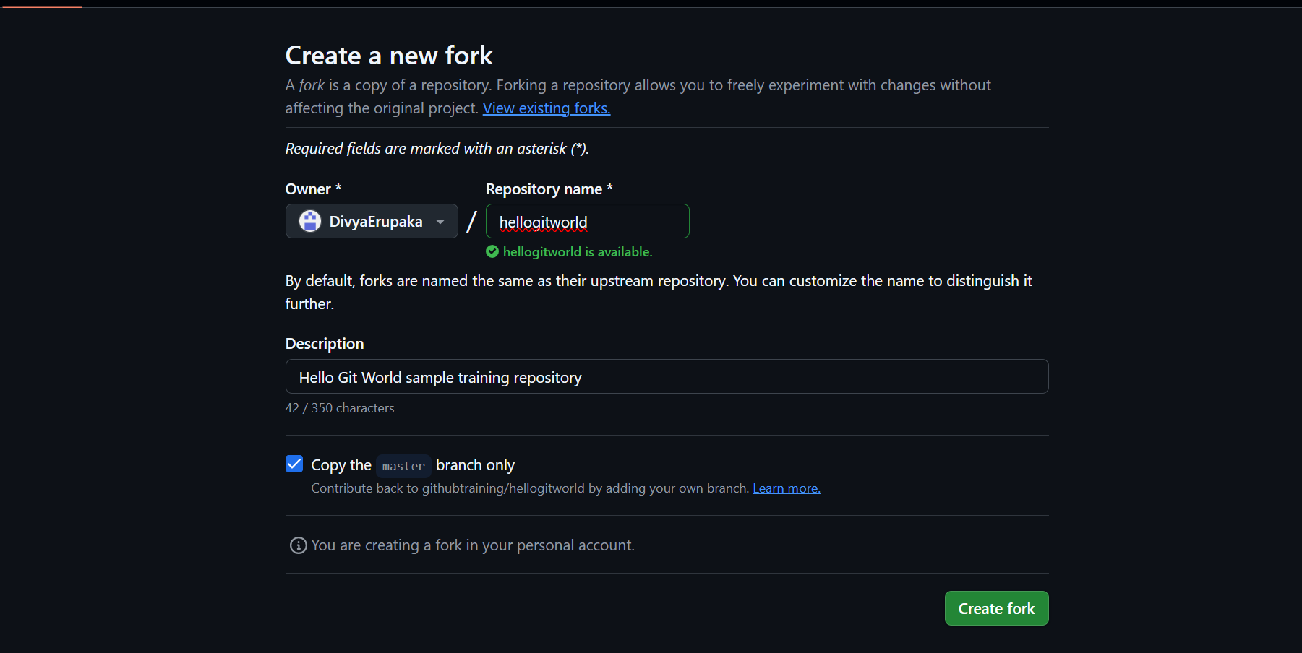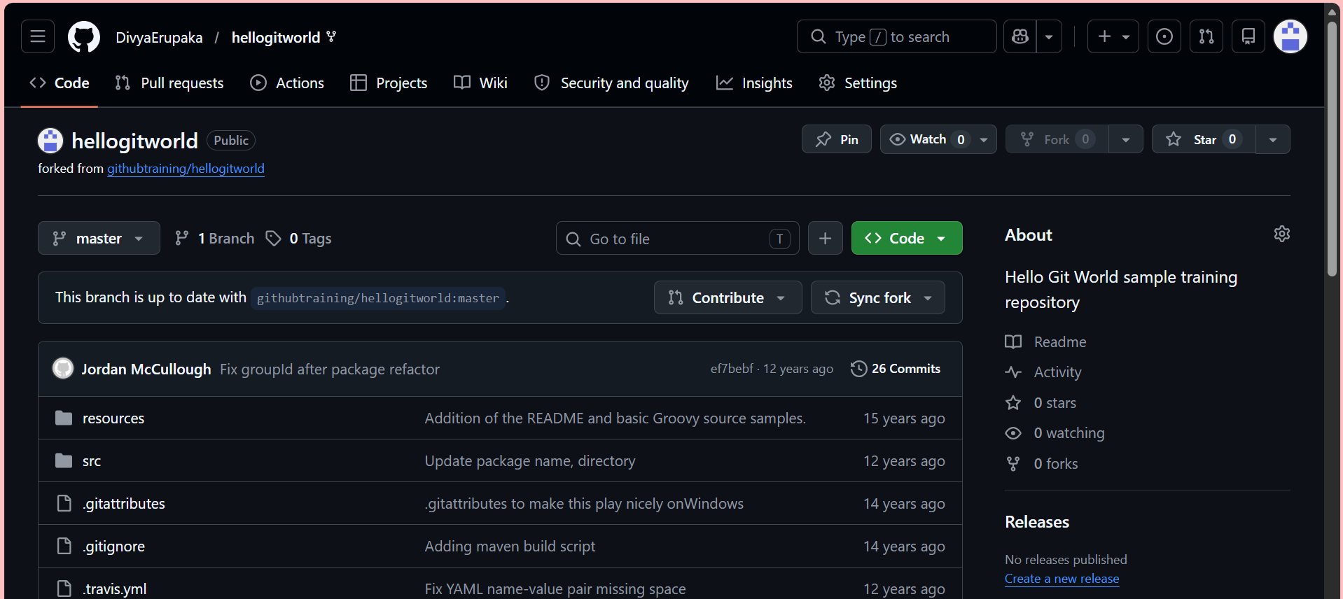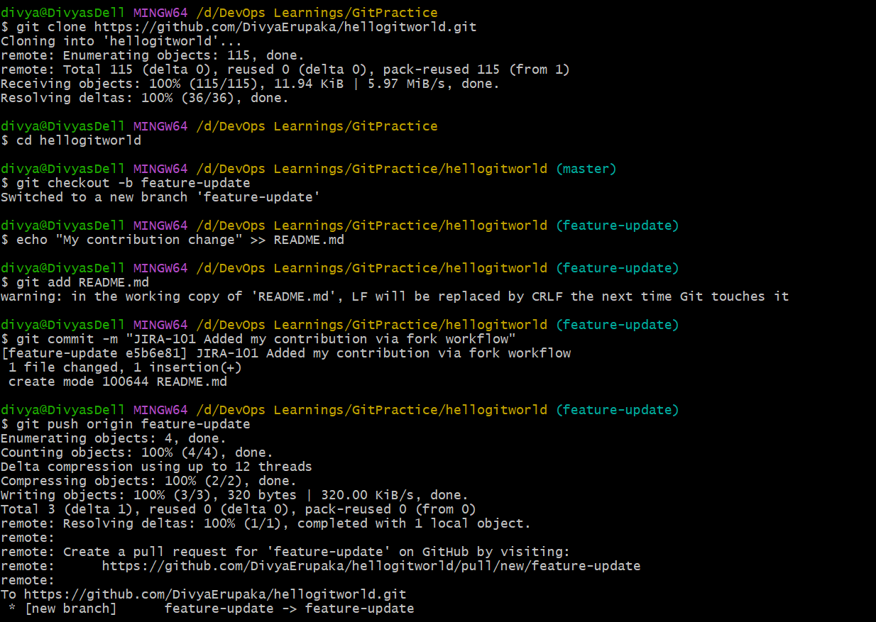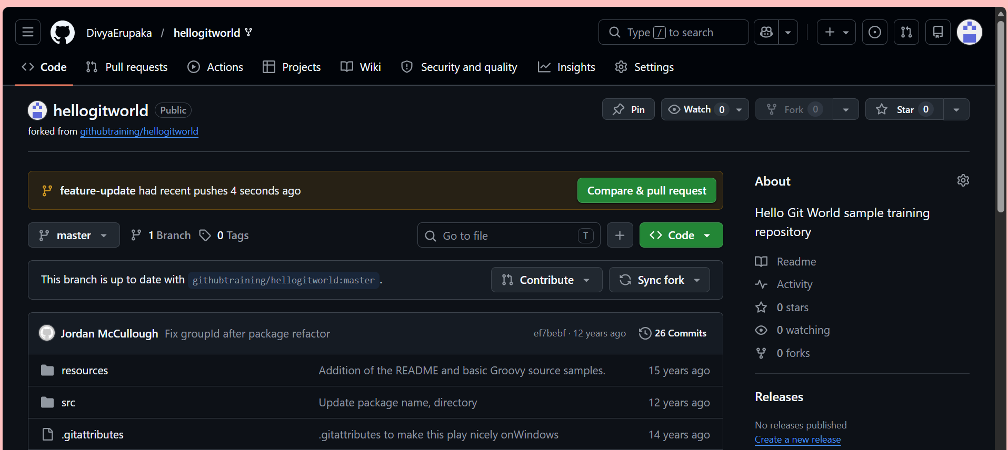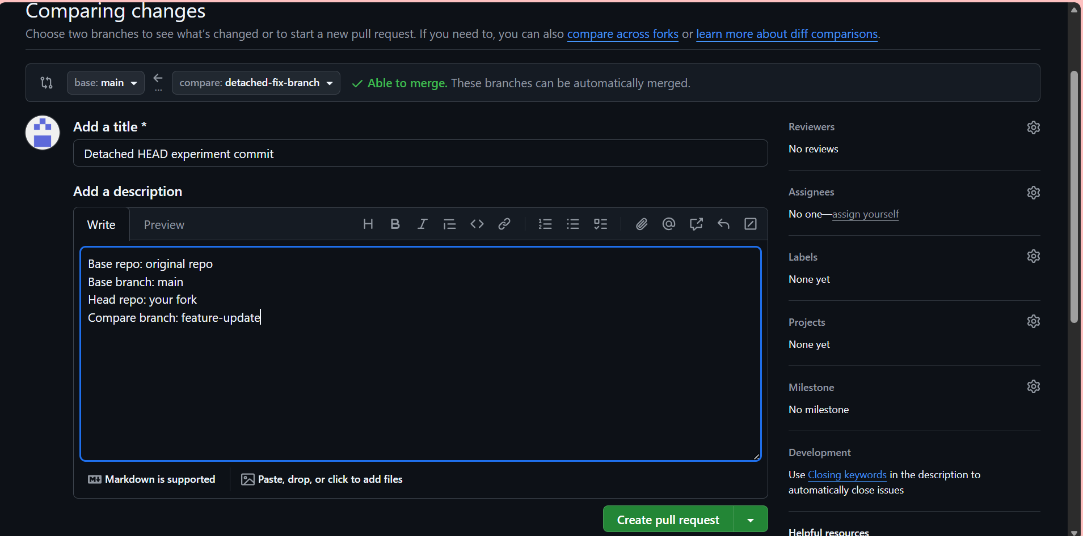
14.
Objective: To demonstrate how to:
- Create a commit
- Delete it using git reset --hard
- Recover it using git reflog

Concept
Command | What it does
git reset --hard | Permanently removes commits from branch history
git reflog | Shows ALL movements of HEAD (even “lost” commits)
recovery | restore commit using commit hash from reflog

Step 1: Create a commit
echo "This is a recoverable commit" > recover.txt
git add recover.txt
git commit -m "JIRA-201 Add recoverable commit"

Step 2: Verify commit exists
git log --oneline
Example output:
a12b3c4 JIRA-201 Add recoverable commit

Step 3: Delete commit using hard reset
git reset --hard HEAD~1

What happens now?
- Commit disappears from git log
- File is removed from working directory
- History looks like commit never existed

Step 4: Find lost commit using reflog
git reflog
Example output:
a12b3c4 HEAD@{0}: commit: JIRA-201 Add recoverable commit
b45d6e7 HEAD@{1}: reset: moving to HEAD~1
You can still SEE the lost commit here

Key Insight
Even after reset --hard, Git does NOT immediately delete commits.
They remain in reflog history.
Step 5: Recover the lost commit
Use the commit hash from reflog:
git checkout a12b3c4
OR restore it to main:
git checkout main
git reset --hard a12b3c4

Result
git log --oneline
Now commit is back:
a12b3c4 JIRA-201 Add recoverable commit
